**Marketing First Class Automobiles’ Operating System Using The 7Ps Marketing Model**

By:

Course

Professor

University

City

Date

**Executive Summary**

In the recent past, the luxury vehicle market has significantly grown, and possibilities of further success especially among the upper social class. First Class International Automobiles is an English luxury automotive brand offering self-driving vehicles run using a highly efficient operating system. Effective incorporation of the 7ps marketing model can help First Class position its operating system as an efficient luxury brand. This would cost it an equivalent to its expenditure on manufacturing vehicle bodies and parts less the operating system. Possible risks include market uncertainties as the industry is still in the introduction phase of its life cycle, hacking and infringement of intellectual property rights. These uncertainties will be mitigated through limited manufacturing and progressive improvements in the system. An increase in the demand for First Class’s self-driving vehicles and revenue will indicate successful marketing.

**Table of Contents**

**Marketing First Class Automobiles’ Operating System Using The 7Ps Marketing Model** **4**

**1.0 Introduction** **4**

**2.0 New Venture** **4**

2.1 Opportunities 4

2.2 New Venture Introduction 6

2.2.1 First Class Automobiles 6

2.2.1 Target Audience 7

2.4 Stakeholders 8

**3.0 New Service** **9**

3.1 Marketing Mix 9

3.1.1Product 9

3.1.2 Pricing 10

3.1.3 Promotion 10

3.1.4 Place 11

3.1.5 Packaging 11

3.1.6 Positioning 11

3.1.7 People 12

3.2 Risks and Mitigation Strategies 13

**4.0 Budget and KPIs** **13**

4.1 Budget 13

4.2 KPIs 14

**5.0 Conclusion** **14**

**References** **16**

# **Marketing First Class Automobiles’ Operating System Using The 7Ps Marketing Model**

# **1.0 Introduction**

Over the past decade, many manufacturing companies, including Rolls Royce, IBM, and General Electric, have developed their service business (Wennerhorm 2012, p1). These manufacturing industry players are primarily seeking reinvention approaches to regain competitive advantage by looking for alternative value creation approaches (Westergreen 2011, p.13). Contingent on product knowledge, the concept behind these approaches is creating new value-adding services that complement their product offerings through after-sale services ( Mukherjee 2018).

Marketing studies have defined this transition from focusing on products to services as a transaction from goods dominant logic to a service-dominant logic (Vargo and Lusch 2008, p1). The service-dominant approach is instrumental for any firm. It can evolve its operations, culture, and overall strategic outlook to create shared benefits for the company and its customers (Vargo and Lusch 2008, p1).

The 7Ps marketing mix model can enhance the efficiency of the service-dominant logic in any firm. The 7Ps marketing model is a practical framework to evaluate a business based on appropriate approaches while subsequently assessing the marketing mix elements, including products or services, prices, place, promotion, physical evidence, processes, and people (Hanlon 2022).

This report outlines a First Class Automobiles’ global marketing plan built on the 7Ps marketing model.

# **2.0 New Venture**

## **2.1 Opportunities**

In the recent past, the global luxury vehicle market has significantly grown. In 2019, it was worth $449.7 billion, 68% higher than in 2015 (Fortune Business Insights 2022).

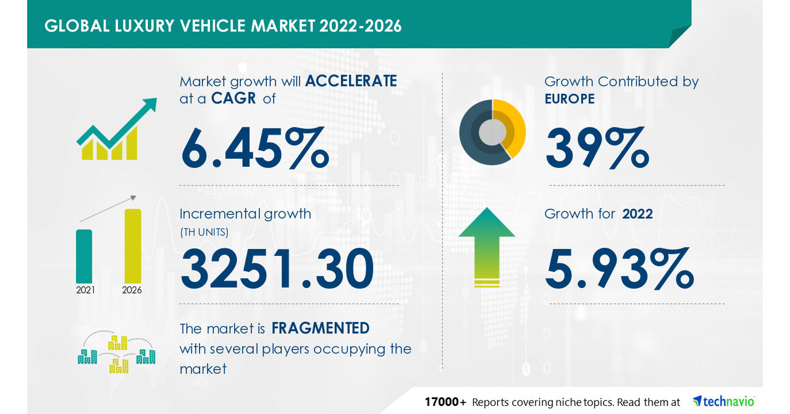

*(Source: Fortune Business Insights)*

As of 2020, China’s luxury car market was valued at $160 billion (Mordor Intelligence 2022). Its annual sales exceeded 3 million units with a 9.3% year on year increase marking the third consecutive year for luxury brands to register growth (Mordor Intelligence 2022).

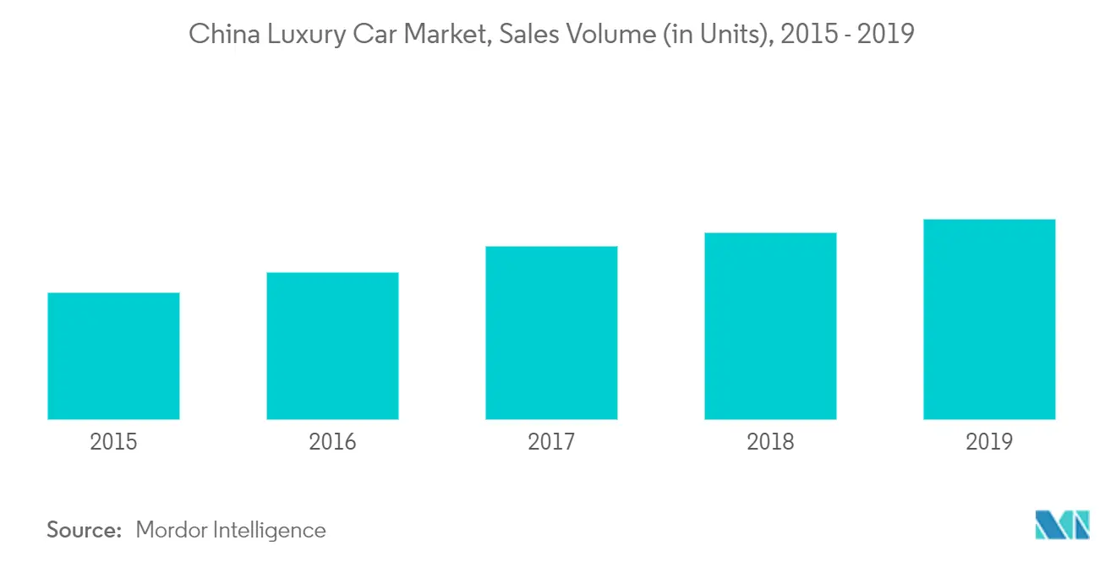

Since 2017, the UAE luxury car market has consistently grown and was valued at $5780.42 Million in 2020(UAE Luxury Car Market 2020).

Odukporo (2021) and Zhang (2019) point out that every industry undergoes development through distinct successive stages through which the products or services progress. These stages include;

* Development
* Introduction
* Growth
* Maturity
* Decline.

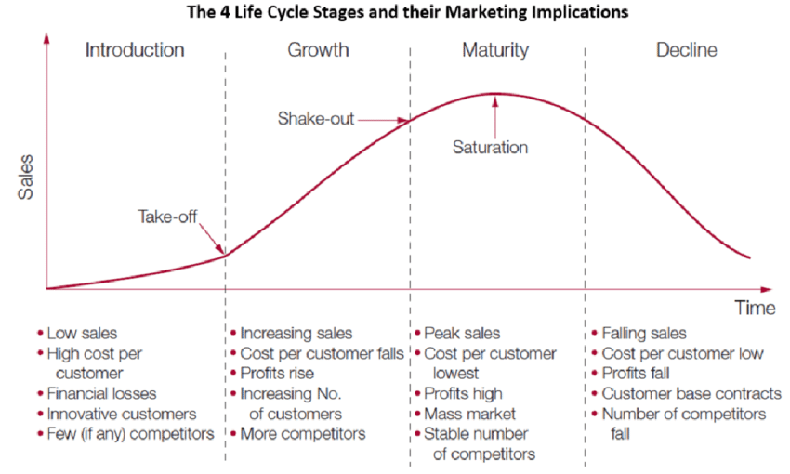

*(Source: Zhang 2019)*

Considering its low sales, the self-driving cars sector is in the introduction stage. With relationship marketing, any strategic company can establish its brand in the industry.

## **2.2 New Venture Introduction**

### **2.2.1 First Class Automobiles**

First Class Automobiles is an English luxury automotive brand headquartered in London, UK. First Class International plans to launch its products and services in January 2023. Its main offering is the operating system in its self-driving cars.

### **2.2.1 Target Audience**

First-class international’s target market is the higher social class across the globe. While dividing or segmenting markets, researchers consider shared characteristics, including shared interests, common needs, similar lifestyles, and shared demographic profiles (Camilleri 2018, p.69). Common market segmentation criteria include

* Demographic
* Psychographic
* Behavioral
* Geographic
* 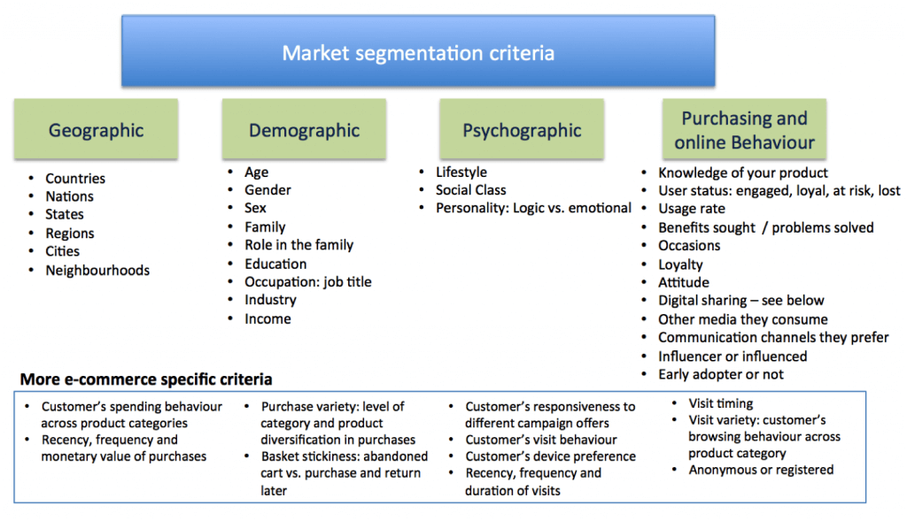

*(SourceCamilleri 2018)*

The upper social class across the globe has a shared lifestyle that emphasises the quality and value of the physical attributes of an automobile (Lansley 2018). First Class Stores aims to maximise this market by delivering high-quality services through an efficient operating system for its luxury cars.

## **2.4 Stakeholders**

Relationships marketing theory posit that organisations are a wider network comprising of diverse yet interconnected shareholder groups (Filip 2011). The relationship between these shareholders influences satisfaction and loyalty and thus a firm’s profitability. Effective management of these relationships (Filip 2011, p.15). Based on Foster and Cadogan's (2000, p.85) definition of a shareholder as a party with interests in a company, First Class shareholders include investors, suppliers, employees, regulators and influencers, partners, and customers. To build mutually beneficial relationships with all stakeholders, First Class will incorporate the Relationship Model of Selling. This model describes the process of selling as having four phases: approach, identifying needs, making the presentation and resistance, and gaining commitment (Foster and Cadogan 2000, p.184). While approaching entails building trust, identification of needs involves asking questions and listening to the stakeholders. Marking the presentation involves the sale of benefits. For employees, that may involve the provision of better working conditions and availing training and development opportunities. Reassurance and gaining commitment may include consistent delivery of value. For suppliers, this will involve timely payment and consistent communication.

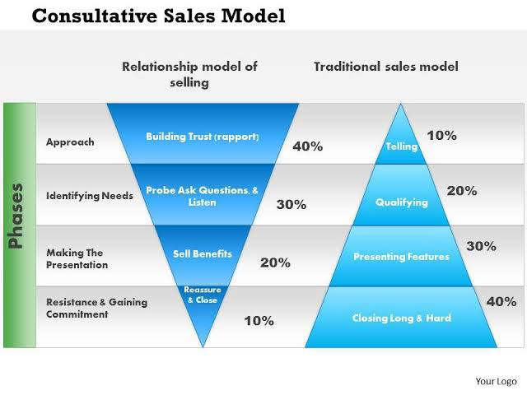

*(Source: Slideteam.net)*

# **3.0 New Service**

## **3.1 Marketing Mix**

### **3.1.1Product**

First Class Automobiles service offering is a system that relies on acrobatics, sensors, complex algorithms, machine learning systems, and powerful processors to execute software. Through extensive research and development, First Class International has unveiled chips and less costly sensors to manufacture cameras that enhance visibility and wipers that clear the lidar system. This system enables full autonomy as the lasers can detect objects up to 300 meters away, and sensors can give 360-degree views. With this system, customers will be able to virtually self-drive across the globe. Bhasin (2022) cites that a firm can effectively counter competition by having a unique selling proposition. First class's service will be differentiated from the competition by efficiency. Through intensive research and development, First Class will ensure that every operating system is tested for at least a year before it is launched.

### **3.1.2 Pricing**

First Class will incorporate a premium pricing strategy. Dean (1976) emphasises on-demand estimation, the anticipation of the impacts of diverse possible price combinations, and the selection of the most appropriate promotion policy, especially in the early stages of the competition.

Luxury has a psychological connection with premium pricing (Allsop 2004). The premium value of a product or service is its price, quality, style, intangibles, experience, occasion, and uniqueness (Allsop 2004).

Manoukian (2019) posits that luxury car buyers are more likely to crave social status and material wealth. Brand reputation and quality of the product offerings are therefore key determinants of luxury. The unique capabilities and experience offered by the First Class Automobiles operating system qualifies the brand as a luxury brand, and thus the premium pricing strategy.

### **3.1.3 Promotion**

Primarily, First Class will incorporate a luxury marketing strategy to promote its operating system. Luxury marketing encompasses the delivery of top-notch experience through the performance of the services offered, a history of the brand's mystique, offering limited edition products, and justified high-end pricing to maintain the perceived value (Yeoman and McMahon-Beattie 2006).

Relationship marketing in the service-dominant logic emphasises value proposition, co-creation of value and application of specialised skills and knowledge through deeds, processes and performances (Vargo and Lusch 2008, p2). First Class will achieve this through consistent improvement and response to customer feedback on desired changes to improve the program’s performance and thereby create value for its customers. This positive relationship will make customers become brand loyal to the extent that this loyal customer base leads to a decrease in marketing costs, provides a reliable and efficient communication route for lifting the company, makes it challenging for the competitors to have access and allows setting of higher prices (Foster and Cadogan 2000).

### **3.1.4 Place**

First Class’s unique operating system will only be available in vehicles manufactured by First Class. To maximise customer experience, First Class will sell its products directly from its official website. Here, customers will provide distinct information specifics such as their location, preferred colours, shipping address, and registration details. Besides enhancing customer experience, direct sales from the website will help the company inquire about customer preferences and needs from the operating system. This will give the company insights into the operating system's features to improve in the subsequent versions.

### **3.1.5 Packaging**

Packaging in the service sector is covered by brand association, using the service, tools, and pricing (Hanlon 2022). First Class Automobiles’ operating system is built to support both Android and Apple devices. Therefore, users of both OSs can effectively run the vehicles’ operating systems using their devices.

In a bid to enhance the luxury aspect of the brand, the First Class operating system will support voice recognition such that users can operate it using their voice with or without their mobile devices.

First Class Automobiles operating system stands out among other offerings due to its efficiency. Marketing research defines a good positioning as one that makes a product or service unique and leads the customers to consider its as of distinct benefit to them (Camilleri 2017). The primary concern over self-driving cars is their efficiency.

### **3.1.6 Positioning**

To avoid this and therefore stand as the most efficient brand in the industry, First Class will rely on research and development. A system will undergo various tests over years before they are launched in the market to assess and correct any possible bugs and risks. Besides enhancing customer experience, an efficient system with zero bugs or failures throughout the life of a self-driving car will counter the public criticism (Clifford Law 2021) against self-driving cars over fears of system failures that could increase accidents.

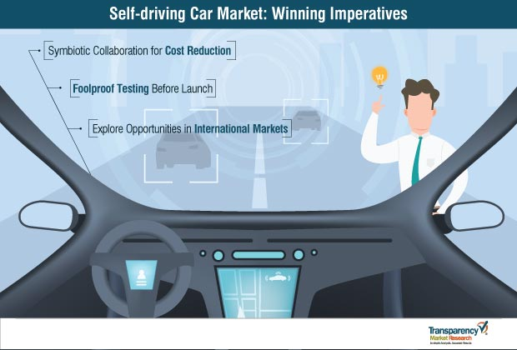

*(Source: Transparency Market Research)*

### **3.1.7 People**

Modern marketing theories emphasise recognising the people involved in the marketing process (Hanlon 2022). People directly or indirectly involved in designing, developing, and installing the First Class’s operating system include software engineers, mechanical engineers, marketers, and customer care representatives. Collectively, these people will be expected to ensure that their undertakings are centred on customer experience. For instance, a software engineer, when developing or improving the system, a software engineer will be required to always think about what improvements can be made to enhance the customer experience in interaction with the system. Such people will be selected based on their experience and commitment to perfection. Commitment towards perfection aligns with First Class vision of offering seamless self-driving vehicle operating systems throughout the life of a vehicle.

## **3.2 Risks and Mitigation Strategies**

Considering that the self-driving vehicle industry is in the introduction stage of its life cycle, the future of its operating systems, customer needs, competition, and development are unknown (Aulum 2018). The limited offer strategy introduced above is among the strategies to mitigate such risks.

With a limited number of products, a company is saved from uncertainties in the market (Pacific Research Laboratories n.d). A change in law requiring, for instance, self-driving cars to have specific standards might lead a firm to immense losses if it had already invested heavily in software that does not meet the required standards.

Failure of a system or hacking can seriously affect the brand image and lead to legal issues. The stability of a system is hugely reliant on how the user interacts with it. Therefore, irrespective of the safety measures incorporated by the developer, the AI incorporated and features such as Bluetooth make self-driving vehicles susceptible to hacking (Brodsky 2021). A self-driving car’s system failure can cause accidents and loss of property which could seriously affect the company’s positioning as an efficient and luxury brand.

First Class Automobiles' marketing for its self-driving vehicle operating system is likely to face intellectual property risks. Third parties may make unauthorised use of the operating system’s strategic information (JonesDay 2021). On a global scale, these risks increase tenfold due to the difficulties in defending rights remotely (Hernandez 2018). These risks will be alienated by constant modification and improvement of the operating system to stay ahead of the competition.

# **4.0 Budget and KPIs**

## **4.1 Budget**

Considering the sensitivity of a self-driving car operating system to both the customers and the company, First Class needs to invest heavily in research and development, and tests. Research and development will therefore take up 60% of the capital set out for the manufacture of self-driving cars. Besides, considering that the experience from the operating system is the primary offering of First Class’s self-driving vehicles, a higher investment than in the physical aspect of the car is reasonable.

## **4.2 KPIs**

Increased demand and revenue growth from the sale of self-driving vehicles are the primary KPI for First Class’s marketing plan for its self-driving car operating system. An increase in revenue will be an indicator that the company has developed a system that meets customer needs and enhances their overall experience.

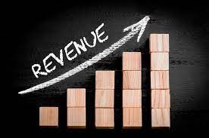

*(Source: Growthbusiness.co.uk)*

# **5.0 Conclusion**

Recently, manufacturing companies have rapidly entered the service industry to maximise their experience for new competitive advantages. Contingent on product knowledge, the concept behind these approaches is creating new value-adding services that complement their product offerings through after-sale services. First Class Automobiles intends to maximise this shift by offering a self-driving vehicle operating system for its vehicles. Effective incorporation of the 7ps marketing model can help First Class position its operating system as an efficient luxury brand. This would cost it an equivalent to its expenditure on manufacturing vehicle bodies and parts less the operating system. Possible risks include market uncertainties as the industry is still in the introduction phase of its life cycle. These uncertainties will be mitigated through limited manufacturing. An increase in the demand for First Class’s self-driving vehicles and revenue will indicate successful marketing.

# **References**

Allsop, J. (2004). ‘*Premium pricing,’ paper presented at the Future Foundation Changing Lives Conference,* *2nd December.* Queen Elizabeth Conference Centre, London.Available at: [Accessed 30/04/2022].

Aulum, A. (2018). *“The uncertain future of self-driving cars.”* Data-Driven Investor. Available at: <https://medium.datadriveninvestor.com/the-uncertain-future-of-self-driving-cars-a7b077c9800a> [Accessed 30/04/2022].

Berggren, U. & Bergkvist, T. (2006). *“Industrial Service Innovations - A Disregarded Growth Engine.*” Available at:<https://www.unido.org/sites/default/files/2009-02/IDR_2009_print_0.PDF> [Accessed 29/04/2022].

Bhasin, H. (2022). *“Luxury brand marketing-concept and strategies.”* Marjetung91. Available at <https://www.marketing91.com/luxury-brand-marketing/> [Accessed 29/04/2022].

Brodsky, S. (2021). “How Self Driving Cars Can Be Hacked.” Lifewire. Available at: <https://www.lifewire.com/how-self-driving-cars-can-be-hacked-5114337#:~:text=A%20new%20report%20by%20the,other%20people%20on%20the%20road>. [Accessed 30/04/2022].

Camilleri, M. (2017). *“Market segmentation, targeting, and positioning.”* ResearchGate. Available at:<https://www.researchgate.net/publication/319085560_Market_Segmentation_Targeting_and_Positioning/citation/download> [Accessed 29/04/2022].

CFI.(n.d). *Industry life cycle*. Available at <https://corporatefinanceinstitute.com/resources/knowledge/strategy/industry-life-cycle/> [Accessed 29/04/2022].

Clifford Law. (2022). “The dangers of driverless cars.” *The National Law Review,* vol.12, no.120.

Dean, J. (1976). *“Pricing policies for new products.”* Harvard Business Review. Available at: <https://hbr.org/1976/11/pricing-policies-for-new-products> [Accessed 29/04/2022].

Filip, A. (2011). *“The role of stakeholders in relationship marketing theory.”* ResearchGate. Available at: <https://www.researchgate.net/publication/293075735_The_role_of_stakeholders_in_relationship_marketing_theory> [Accessed 30/04/2022].

Fortune Business Insights. (2022). *“The global luxury car market size was USD 449.7 billion in 2019 and is projected to reach USD 655.0 billion by 2027, exhibiting a CAGR of 9.3% during the forecast period.”* Available at: <https://www.fortunebusinessinsights.com/luxury-car-market-104453> [Accessed 30/04/2022].

Foster, B. & Cadogan, J. (2000). “Relationship selling and customer loyalty: An empirical investigation.” *Marketing Intelligence & Planning,* vol.18, p.185-199.

Furuno. (n.d). *“The Automobile industry is shifting from a manufacturing industry to a service industry.*”Available at: <https://www.furuno.com/en/its/articles/20170324/> [Accessed 29/04/2022].

Hanlon, A. (2022). “*How to use the 7Ps Marketing Mix.”* Smart Insights. Available at: <https://www.smartinsights.com/marketing-planning/marketing-models/how-to-use-the-7ps-marketing-mix/#:~:text=The%207Ps%20marketing%20model%20was,in%20his%20book%20Basic%20Marketing>. [Accessed 29/04/2022].

Hernandez, E. (2018). *“Why Strong intellectual property law matter in a globalized world.”* Knowledge at Wharton. Available at: <https://knowledge.wharton.upenn.edu/article/globalization-and-its-impact-on-inequality-for-companies/> [Accessed 30/04/2022].

IEA. (2021). “*Trends and developments in electric vehicle markets.”* Available at: [**https://www.iea.org/reports/global-ev-outlook-2021/trends-and-developments-in-electric-vehicle-markets**](https://www.iea.org/reports/global-ev-outlook-2021/trends-and-developments-in-electric-vehicle-markets)[Accessed 29/04/2022].

JonesDay. (2017). *“New Intellectual Property Considerations and Risks for Autonomous Vehicles.*”Available at: <https://www.jonesday.com/en/insights/2017/05/new-intellectual-property-considerations-and-risks-for-autonomous-vehicles> [Acessed 30/04/2022].

Lansley, G. (2016). “Cars and socio-economics: Understanding neighbourhood variations in car characteristics from administrative data.” *Regional Studies, Regional Science.* vol.3, pp.264-285.

Manoukian, J. (2019). *“The psychology of luxury car buyers: 7 considerations”* Limelightplatform. Available at: <https://www.limelightplatform.com/blog/psychology-luxury-car-buyers-considerations#:~:text=Thus%2C%20those%20who%20buy%20luxury,quality%20to%20attract%20these%20customers>. "[Accessed 29/04/2022]

Mordor Intelligence. (2022). *“China luxury car market- growth, trends, Covid-19 impacts, and forecasts (2022-2027). ”* Available at: <https://www.mordorintelligence.com/industry-reports/china-luxury-car-market> [Accessed 30/04/22].

Mordor Intelligence. (2022). *“Europe luxury car market-growth, trends, Covid-19 impact, and forecasts (2022-2027).* Available at: <https://www.mordorintelligence.com/industry-reports/europe-luxury-car-market> [Accessed 29/04/2022].

Mukherjee, S. (2018). “*Carmakers focus on after-sales service.”* Business Standard. Available at: <https://www.business-standard.com/article/companies/car-makers-focus-on-after-sales-service-110121300039_1.html> [Accessed: 30/04/22].

Pacific Research Laboratories. (n.d). *“What Are The Benefits of Short Run Production?”* Available at: <https://www.pacific-research.com/what-are-the-benefits-of-short-run-production-prl/> [30/04/2022].

Shingetsu. (2020). *“UAE luxury car market.”* Available at: <https://www.shingetsuresearch.com/uae-luxury-car-market/#:~:text=UAE%20Luxury%20car%20market%20was,comfortable%20seats%2C%20and%20unique%20design>. [Accessed 30/08/2022].

Udokporo, C. (2021). *“Understanding the stages of the product life cycle.”*  Chapter Metrics Overview. Available at: <https://www.intechopen.com/chapters/77641>[Accessed 30/04/2022]

Vargo, S. L. and Lusch, R. F. (2008). “Service-dominant logic: Continuing the evolution.” *Journal of the Academy of Marketing Science, vol.36, no.1, pp.1- 10.*

*Wennerholm, E. (2012). “Transitioning from a goods-dominant to a service-dominant logic: Visualizing the role of remote monitoring systems.”* Available at: <https://www.diva-portal.org/smash/get/diva2:539625/FULLTEXT01.pdf> [Accessed 30/04/2022].

Westergren, U. H. (2011). *“Disentangling Sociomateriality: An Exploration of remote monitoring systems in inter-organizational networks.”* Umeå: Umeå University.

Yeoman, I. and McMahon-Beattie, U. (2006). “Luxury markets and premium pricing.” *Journal of Revenue & Pricing Management, vol.*4.

Zhang, Li. (2019). "Research on the relationship between financial correlation and financing constraints of small and medium power plants.” *IOP Conference Series: Materials Science and Engineering, vol.*  677.